Bannister Facility
Community Involvement Plan

March 2019

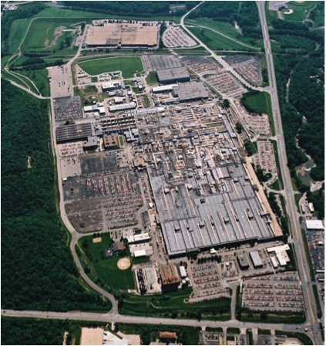

Contents

Executive Summary 3

1. Introduction, Facility Description and History 3

2. Environmental Investigations 5

3. Community Profile 9

4. Past Community Involvement Activities 9

5. Current Community Needs and Concerns 12

6. Future Community Involvement Activities 12

7. Conclusion 14

Appendix

Appendix 1. Site Contacts 15

Appendix 2. History Timeline 19

Appendix 3. Demolition and Redevelopment Timeline 22

Figures

Figure 1. The Bannister Facility Cover

Figure 2. Project Location of the Bannister Facility in the Kansas City Area 4

Figure 3. Map of the SWMUs at the Property 8

Executive Summary

This Community Involvement Plan (CIP) has been prepared for community involvement activities associated with a Missouri Hazardous Waste Management Facility Part I Permit and U.S. Environmental Protection Agency (EPA) Hazardous and Solid Waste Amendments Part II Permit. Together, these two documents are referred to as the hazardous waste permit. This plan is a continuation of the ongoing communication efforts regarding the former Bannister Federal Complex, now referred to as the Bannister Facility (facility). This CIP covers the portion of the facility currently owned by Bannister Transformation & Development LLC (BTD). This CIP does not cover the 82 acres of property east of the Union Pacific railroad tracks, which are owned and operated by the U.S. General Services Administration (GSA). See Figure 3.

The goal of the CIP is to encourage active communication between BTD and the nearby South Kansas City community. The CIP outlines BTD’s plan to deliver and receive timely information from the community and stakeholders. The CIP helps with two-way communications regarding major milestones and questions or concerns related to the hazardous waste permit, corrective measures activities, demolition, and the future re-use plans for the property. The CIP also outlines ways in which the community and stakeholders can participate throughout the cleanup process. BTD will review this CIP every five years or when major/milestone events are reached, and update the plan, as necessary, to reflect community preferences, as well as activities occurring at the BTD-owned portion of the property.

1. Introduction, Facility Description and History

The former Bannister Federal Complex (BFC) consisted of approximately 307 acres located at Bannister Road (95th Street) and Troost Avenue in Kansas City, Missouri. In the early 1900s, the area in and around the entire site was mainly farmland, except for the construction and brief operation of the Kansas City Speedway (a 1.25-mile wood oval track) between 1922 and 1924. In 1942, the federal government (through the federally-owned Defense Plant Corporation) took possession of the property and constructed the original main manufacturing building. Between 1943 and 1945, Pratt and Whitney Corp. built aircraft engines in the main manufacturing building for the U.S. Navy in support of World War II.

In 1948, the main manufacturing building was transferred to the War Assets Administration, which used the building as a warehouse and for occupancy by several private and governmental entities. Thereafter, the land and buildings were transferred to the U.S. Department of the Navy, which leased part of the building to Westinghouse Electric Co. in 1948. Westinghouse built jet engines for the federal government until 1961.

In 1949, Westinghouse subleased part of the main manufacturing building to Bendix Corp. The Atomic Energy Commission (AEC) contracted Bendix to manufacture electrical, mechanical, plastic and other non-nuclear components of nuclear weapons and systems. In 1962, most of the Bannister Facility was transferred to GSA, with the agreement that Bendix would continue to operate in their part of the main manufacturing building. Between 1984 and 1999, Bendix merged with Allied Corp., which merged with the Signal Companies and changed its name to AlliedSignal. In 1999, AlliedSignal merged with the Honeywell Corporation, and adopted the name Honeywell Federal Manufacturing & Technologies LLC. Over the years, the manufacturing areas of the property came to be known by several names, including the Kansas City Plant (KCP), Bendix Plant and Honeywell Plant. The KCP operated on approximately 136 acres of the 307-acre site.

The AEC reorganized into the Energy Research and Development Administration in 1975 and took custody and control of the KCP. In 1977, the U.S. Department of Energy (DOE) was created and took custody and control of the KCP. In 2000, Congress created the National Nuclear Security Administration (NNSA), in part, to strengthen national security and reduce the global threat from weapons of mass destruction. NNSA was established as a smaller agency within the DOE. Through each of these transitions, Bendix, now Honeywell, continued to operate the KCP.

Figure 2. Bannister Facility Location in the Kansas City Area
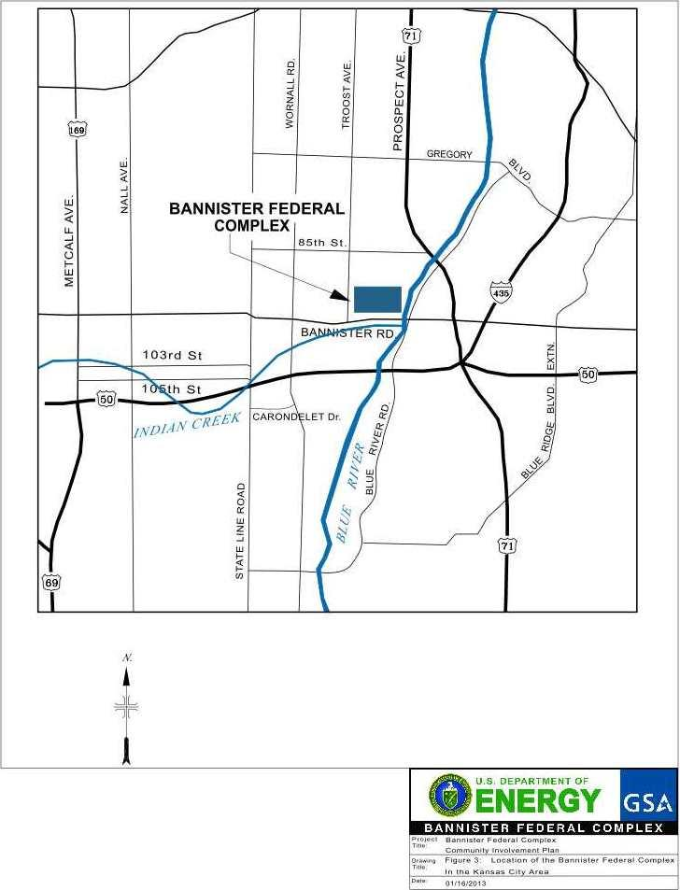
N

The KCP manufactured electrical, mechanical, plastic, and other non-nuclear components of nuclear weapons and systems. A variety of hazardous wastes were produced as part of the plant operations, such as acids, solvents, waste oil, wastewater treatment sludge and toxic metals. These wastes were stored on the property until disposed off-site at a permitted hazardous waste treatment, storage and disposal facility or treated at the on-site industrial wastewater pretreatment facility. The KCP operated six hazardous waste container storage areas and three contingent storage areas under hazardous waste generator storage requirements.

According to DOE records, the KCP handled uranium in the early 1950s, producing slugs (fuel rods) from
10-foot long uranium rod stock, which were used to fuel the Savannah River site in South Carolina and Argonne National Laboratory. The KCP also used small amounts of radioactive materials in products, and used conventional, sealed sources for instrument calibration, radiography and laboratory equipment. These processes occasionally produced radiological and chemical waste, which was stored in one mixed waste container storage area, until shipped off-site for disposal. For details about uranium use at the KCP, please refer to the Description of Current Conditions Report (DCCR), Section 7.1 Uranium at the BFC KCP, which can be found online at http://bit.ly/DCCRSection7-1.Records also indicate that manufacturing activities using beryllium were performed at the KCP as early as 1963. Beryllium dust was produced when certain copper alloys that contain beryllium were machined at the site. For details about beryllium use at the KCP, please refer to the DCCR, Section 7.9 Beryllium at the BFC, which can be found online at http://bit.ly/DCCRSection7-1.

In 2014, DOE/NNSA stopped manufacturing operations at the KCP and relocated to the National Security Campus, located on Botts Road in South Kansas City. Shortly thereafter, GSA moved its operations to downtown Kansas City. GSA property west of the Union Pacific railroad tracks, which run north and south across the property, was used for administrative office space and warehousing. Several other federal agencies occupied portions of the GSA space. By the end of 2015, federal agencies on GSA property west of the railroad tracks had moved to new locations. GSA continues to own the property and building east of the railroad tracks, which it leases to the U.S. Marine Corps.

On November 15, 2017, the federal government transferred title to 225 acres of the property west of the railroad tracks to BTD to facilitate cleanup and redevelopment of the site. An additional two acres located at 9051 Troost Avenue were included in the transfer. The two acres off-site are federal land unrelated to the Bannister Facility and contains a cellular tower. GSA kept ownership of the remaining 82 acres east of the railroad tracks. In December 2017, BTD requested the hazardous waste permit for the property be changed to name BTD as owner and operator of that portion of the permitted property transferred to BTD. On January 22, 2018, the Missouri Department of Natural Resources (DNR) approved the request and added BTD to the Part I Permit as a co-permittee with GSA. On January 26, 2018, EPA changed the Part II Permit to be consistent with the Part I Permit. BTD is in the process of redeveloping the area of the permitted property under its ownership.

Additional information about the facility history and operations is available in the administrative record. Hard copies can be reviewed at the locations listed in Section 6.4 Library Technical Document Repository
of this CIP.

2. Environmental Investigations

Over the decades, there were several solvent and oil spills and leaks at the facility. There are two known historical releases of polychlorinated biphenyls (PCBs), which were used in transformers, other electrical equipment, hydraulic oil, caulking compounds and elastic sealant. In 1969, an expansion joint failed and released approximately 1,500 gallons of PCB oil to a gravel area near the main manufacturing building. About 900 gallons of the PCB oil entered the storm sewer system and was released to Indian Creek. Despite clean-up efforts at the time of the spill, residual PCBs remained in the creek bottom sediments. Shortly after the spill, Indian Creek was rerouted, and PCB contamination was left in place in deep soil alongside and underneath the box culvert that channels storm water under Bannister Road, via Outfall 002, to the relocated Indian Creek. This contaminated area became known as the 95th Terrace site. In 1971, about 1,100 gallons of oil containing PCBs were released to the ground near a storm water drain. Some of this oil entered the storm sewer system and was released to Indian Creek. Again, cleanup was performed. In 2005, an outfall re-route system was completed to divert low flow to the on-site groundwater pretreatment system. The re-routing resulted in a significant reduction in PCB entering Indian Creek from the outfall.

These spills, and other leaks, contaminated soil and groundwater at the facility. Most of the releases occurred at the facility before most federal regulations were in place and before industry understood the environmental impacts created by certain materials and operations. Both DOE/NNSA and GSA performed environmental investigations and cleanup at the property for more than 30 years. EPA was primarily responsible for providing regulatory oversight until the late 1980s when DNR became the lead agency. DOE/NNSA identified 44 specific areas of soil and groundwater contamination, called Solid Waste Management Units (SWMUs), on the property now owned by BTD. The main contaminants of concern identified over this period include PCBs and chlorinated solvents; particularly trichloroethylene (TCE). Semi-volatile organic compounds, including a variety of polyaromatic hydrocarbons (PAHs), are also present in soils. In localized portions of the property, PCBs are the main contaminant, primarily near the southeast corner of the main manufacturing building.

Three SWMUs have been closed and are now undergoing long-term monitoring and maintenance. Potentially contaminated soil in known SWMUs is managed according to a DNR-approved Soil Management Plan. As part of the demolition, regrading and redevelopment stage, BTD will perform additional corrective measures as part of the overall site redevelopment. Additional information on BTD corrective measure can be found at http://bit.ly/CorrectiveMeasures. Existing deed restrictions prevent the use of groundwater. The current groundwater remedy requires removing the contaminated groundwater through pumping extraction wells, building sumps and building footing tile drains, and treating the groundwater in the on-site groundwater treatment facility.

Federal property can be transferred to a private owner before the environmental cleanup is complete. However, the National Environmental Policy Act (NEPA) requires the federal agencies to consider the environmental consequences of their proposed actions before making decisions. The DOE/NNSA prepared an Environmental Assessment (EA) to evaluate the potential environmental impacts of its proposal to transfer excess BFC property to a new owner. The EA is available online at http://bit.ly/EnvironmentalAssessment and http://bit.ly/EARevisions.

As required by the 2012 modifications to the Part I Permit, DOE/NNSA prepared a Description of Current Conditions Report (DCCR), which summarized the current sitewide environmental conditions at the BFC. The four-volume DCCR is available online at http://bit.ly/CurrentConditionsReport. The DCCR summarizes the historical information, including an extensive array of tables and figures, associated with environmental investigations performed at the property. The DCCR summarizes the sampling results used to define the environmental conditions at the site and what led to the site being addressed under hazardous waste clean-up authorities. The DCCR also reviews the geologic conditions (subsurface soil and rock) at the site and the nature and type of actual contamination found at the BFC. The report discusses how this contamination behaves in the subsurface, along with how the subsurface soil and rocks’ physical and chemical properties influence the flow of groundwater and contamination through it. The report describes and evaluates the impact of stormwater runoff from BFC on local surface water conditions and streams. The DCCR was also used to evaluate and identify any potential “data gaps” with respect to the extent of environmental releases.

A risk screening study was conducted to assess current contaminant levels in environmental media at the BFC. Contaminant levels were compared to environmental screening levels for actual and potential uses of the site. A groundwater modeling study was completed to determine the best way to achieve site groundwater cleanup and how long it would take, including the effects of removing the remaining contamination source areas.

All evidence provided by DOE/NNSA regarding the use of natural and depleted uranium and beryllium at the BFC indicated there were no releases outside the manufacturing areas. DOE/NNSA determined there were no radiological exposure concerns and that the facility qualified for unrestricted use. This determination is available online at http://bit.ly/UnlimitedUse. In May 2013, the Final EA and a Finding of No Significant Impact (FONSI) were published. The Final EA determined that the proposed transfer would not significantly affect the quality of human health and the environment. The FONSI, which is based on the EA, stated the transfer of the property to a new owner would have no significant impact on the environment. Electronic versions of these documents are available online at http://bit.ly/EARevisions. Hard copies can be reviewed at the locations listed in the Library Technical Document Repositories, listed in Section 6 of this CIP.

During this same time, CenterPoint Properties worked under a contract with NNSA to determine the feasibility of transferring the Property for re-use. CenterPoint performed several due diligence activities at the BFC, including sampling, to independently evaluate the environmental conditions. Information regarding the due diligence activities are available online at http://bit.ly/DueDiligenceReport. Hard copies can be reviewed at the locations listed in the Library Technical Document Repositories, listed in Section 6 of this CIP.

Previous land use restrictions and prohibition of groundwater use remain at the site. All buildings on the property under BTD ownership are currently vacant, except the waste water treatment facility. The site is undergoing a complete demolition, with the exception of the groundwater treatment facility. Precautions used during demolition of areas formerly used for work that produced beryllium dust are found in the BFC Abatement and Demolition Plan Supplements, Section 13. Beryllium Areas Decontamination Work Plan, and can also be found online at http://bit.ly/AbatementDemoPlan.

After completing the demolition work, BTD will prepare the site for new industrial development. During building demolition and site regrading, BTD will also perform a comprehensive corrective measures program to clean up residual environmental contamination at the facility. This program is described in a Corrective Measures Report, which is available online at http://bit.ly/CorrectiveMeasures. As a precaution, and to address public concerns about the demolition process encountering radiological material, BTD is using a radiation portal monitor to check all material leaving the site. This will also include materials from specific areas of concern that are planned for reuse.

As specified in the Corrective Measures Report, soil contaminated at levels greater than the site-specific cleanup levels and located at pre-determined depths below the future ground surface will be removed and properly disposed of in permitted landfills. Utilities located at pre-determined depths below the future ground surface will be removed, while remaining utilities will be abandoned in-place. Leaking water mains will be replaced and new utilities will be installed along pathways that avoid known contamination to the greatest extent possible. During demolition and utility removal activities, soils with a strong odor, or other obvious contamination that might impact site reuse, will be removed and properly disposed in permitted landfills. Barriers, such as engineered caps, buildings, concrete or asphalt pavement, will be placed in areas where known residual subsurface contamination requires ongoing engineering controls to limit contact with residual environmental contamination.

To improve site drainage, clean fill will be used to raise the current ground surface level across most of the property. Storm and sanitary sewers and outfalls designated in the Corrective Measures Report will be filled with grout and plugged. There are no ongoing discharges of PCBs to soil or groundwater. Existing sumps will be demolished or filled with concrete or grout. The four regulated surface water outfalls will be filled with concrete-like material. During the demolition phase, stormwater is being collected in four temporary basins and treated before discharge. After demolition, new outfalls will be installed, which will discharge stormwater collected in permanent detention basins to be constructed on the property. Groundwater, surface water, sediment, and fish tissue sampling will continue to monitor historic off-site PCB contamination in Indian Creek and the Blue River.

Contaminated groundwater will continue to be pumped and treated in the groundwater treatment facility; however, the system will be altered and improved. Demolition and redevelopment may impact groundwater levels and potentially the contaminant concentrations. They will also require replacing extraction and monitoring wells in large sections of the groundwater monitoring and extraction network. Barrier walls will be installed around two areas in the former manufacturing areas and in the northeast area of the property, to block contaminants from moving beyond the property boundary. Pumping the groundwater and treating it at the groundwater treatment facility will remove contamination within the barriers. Once site conditions stabilize after demolition and re-grading, the groundwater control system will be adjusted to account for the final site redevelopment plan.

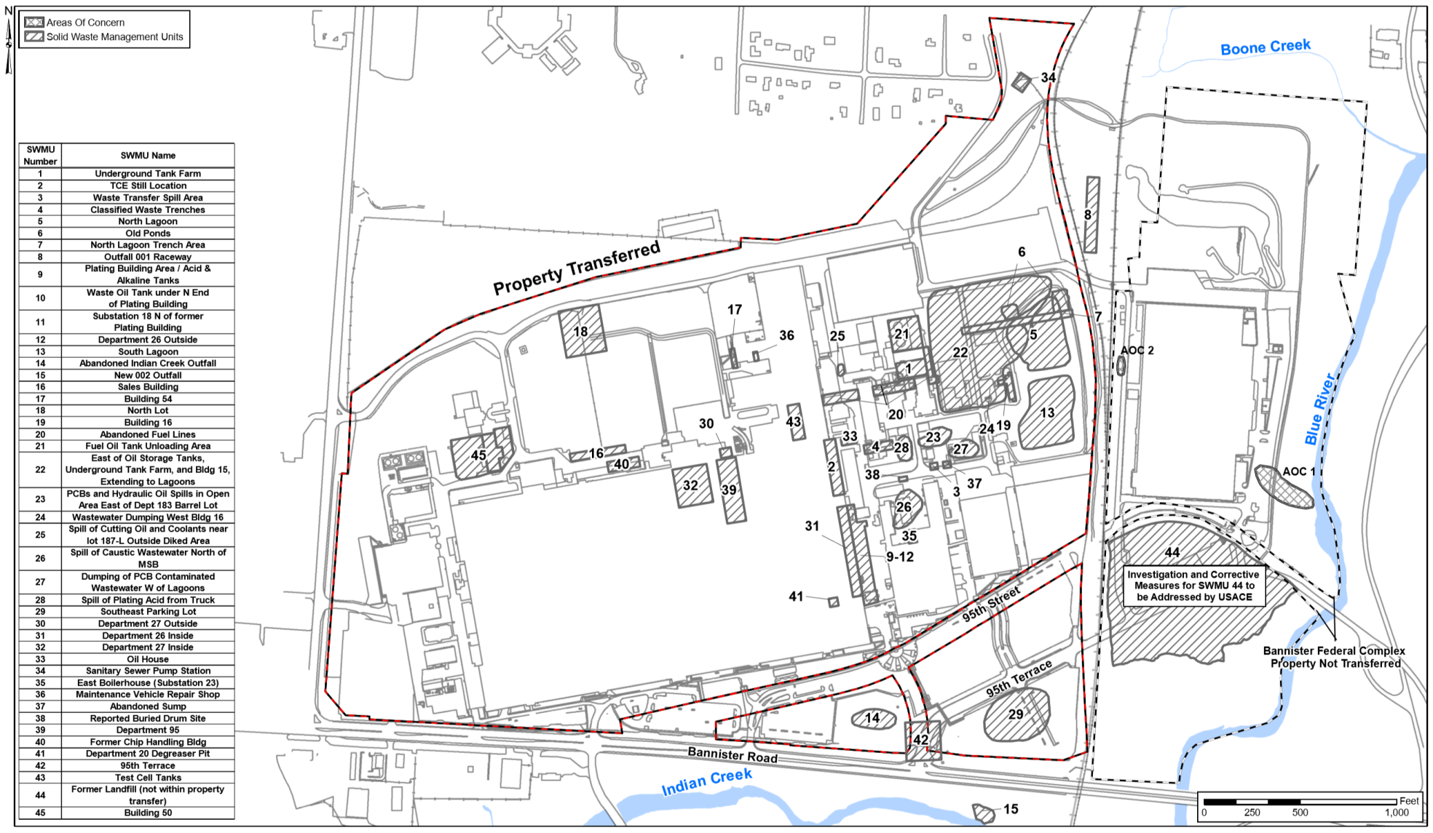
Figure 3. Map of the SWMUs at the property.

Future land use will be commercial or industrial only and restricted under existing land use restrictions, on-site groundwater use restrictions, Deed Restrictions and an environmental covenant. These restrictions include prohibiting residential land use and allowing specific commercial/industrial uses; requiring a soil management plan to govern any activities that disturb potentially contaminated soils; and providing safe working conditions to protect worker health and safety during construction.. Any new buildings will be required to be built with barriers to minimize vapor intrusion, unless DNR determines the barriers are not needed for certain buildings or areas within the building. The only construction style anticipated is slab-on-grade buildings.

3. Community Profile

The facility is located in Kansas City, Jackson County, Missouri. The 15-county Kansas City metropolitan area spans the border between Missouri and Kansas, and is the second largest metropolitan area in Missouri, after St. Louis. It is the largest metropolitan area in Kansas. At the time of the 2010 census (updated every 10 years), the metropolitan area had a population of 2,035,334. The facility is in a part of Kansas City known as South Kansas City, which consists of the southern half of Kansas City, Missouri, as well as the Missouri suburbs of Grandview, Harrisonville, Belton, and Raymore. Jackson County has a population of 674,158 and is the second most populated of Missouri's counties.

For the purposes of this CIP, the community consists of the following groups. For specific contacts, please refer to the contacts listed in Appendix 1 of this CIP.
- Approximately 1,200 area residents in a two-mile radius of the facility.
- Elected officials in Missouri and Kansas, especially those in the Kansas City metropolitan area.
- Special interest groups who want to be involved in the facility environmental and transition process.
- Interested members of the media in Kansas, Missouri and throughout the United States.
- State and federal environmental regulators (DNR and EPA).

4. Past Community Involvement Activities

DNR, EPA, DOE/NNSA and GSA were required to conduct specific public participation activities for certain steps in the hazardous waste permitting and corrective action process, as described in state and federal hazardous waste laws and regulations. The public was notified of these activities through facility mailing lists, newspaper legal notices, radio announcements and news releases, depending on the activity. The permitting documents, remediation plans and other documents were also made available to the public for review and comment.

4.1 Community Newsletters and Surveys

In order to determine information needs and identify the public’s concerns, DOE/NNSA surveyed residents within a 1-mile radius of the BFC and other stakeholders in the surrounding community, via mail in 1990, 1994, 1996, 1999 and 2003. In response to feedback, DOE/NNSA published a quarterly newsletter called FOCUS on the Environment from 1990 until 2006. DOE/NNSA also sent out a newsletter-type flyer for a couple of years called BFC news. In 2006, DOE/NNSA stopped the specific environmental publication and began incorporating environmental stories to reach a wider audience in the organization’s quarterly newsletter Connections, which was made available online.

4.2 Neighborhood Meetings
In 2004, presentations were made to civic groups such as the Linden Hills Neighborhood Association, Blue River Watershed Association and the South Kansas City Chamber of Commerce. The presentations focused primarily on PCBs at the 95th Terrace Site and the potential impact by PCBs on Indian Creek.
In 2011, BFC representatives attended neighborhood association meetings to increase awareness of the current property transfer and disposition activities. In January and February 2012, presentations were given at regularly scheduled meetings of the Center Planning Board and Development Council, South Kansas City Council, Marlborough Community Coalition and Southern Communities Coalition.

4.3 Community Involvement Plan

In 2006, DOE/NNSA updated the original CIP, first prepared in the early 1990s, to reflect additional efforts made to communicate to the public about the issues, concerns, and environmental work at the KCP. DOE/NNSA and GSA created a new CIP in 2013, as required by a final hazardous waste permit modification in August 2012. The plan was finalized in June 2013, and later updated in 2016. This CIP is a new plan, written by BTD, as required by a final hazardous waste permit modification that took effect January 2018.
4.4 Community Advisory Panel
To enhance public involvement in BFC issues, a BFC Community Advisory Panel (CAP) was established in 2010. In addition to providing independent input on environmental and redevelopment issues, the CAP also acted as a communication channel and forum for stakeholders within the community surrounding the BFC. For more than three years, meetings were held about once every two months, although there was no set schedule. Members were nominated by key stakeholders in the community and represented different interests, including neighborhood associations, environmental groups, local residents, former BFC workers and economic development organizations. They received briefings from GSA, U.S. Army Corps of Engineers (USACE), DOE/NNSA, EPA, DNR and CenterPoint Properties. The CAP ended in 2013, concluding it had met its objectives.
4.5 Other Public Involvement Activities
Additional public involvement activities conducted since 2010 include:
- A coordinated communications effort among DNR, EPA, GSA, USACE and DOE/NNSA to announce the hazardous waste permit modification request. This activity included public comments, notices, meetings and briefings to the CAP, the media, the public, local and national elected officials, and other key stakeholders.
- Facility tours for CAP members and other stakeholders.
- Briefings to key stakeholders such as the mayor of Kansas City, County Executive of Jackson County, area chambers of commerce, neighborhood associations, the media and other elected officials and stakeholders.
- Participation in other public meetings held by other organizations such as neighborhood association meetings, area chambers of commerce events, etc.
- Public meeting in 2011, regarding the 95th Terrace site. DNR, Agency for Toxic Substance and Disease Registry, and EPA presented their conclusion that PCBs in Indian Creek did not pose a public health risk.
- Public meeting and hearing in 2017, to inform interested individuals of proposed permit and property transfers.

4.6 Community Interviews

In February 2012, a professional survey company contracted by DOE/NNSA and GSA, conducted community interviews with 21 individuals to gather information that would be useful in revising this plan. A third party was used to perform the interviews to increase the openness of the responses, since some persons may not be as outspoken about their concerns or issues if the interviews were conducted by BFC employees. The interview group consisted of CAP members, randomly selected area residents and members of special interest groups. The individuals who took part in this research were intended to be a random sampling of community members – from those with detailed, firsthand knowledge of the BFC to those whose only source of information was the local news media, to those whose level of awareness of the BFC was not much more than its location and that it is a “government facility.” The process was qualitative in nature, reflecting the thoughts, ideas and concerns of the diverse group of participants. The goal of the research was to determine if the communities’ needs or concerns had changed. The following general themes were identified during the interviews:

Theme 1: Most individuals appeared to have a basic awareness of the BFC, its tenants and its activities, and an even greater awareness of the property’s undetermined future.

Theme 2: The overall opinion of the BFC was also quite diverse. Respondents appeared to get their information from a variety of sources.

Theme 3: With some exceptions, the level of awareness of the specific roles of the parties to the process (DOE/NNSA, GSA and environmental permitting and corrective action process) was limited. The respondents’ interest appeared to be less about who was taking care of the future disposition of the site (both environmental issues and the property transfer) than that it is handled properly and safely.

Theme 4: Traditional news media, well-publicized public meetings, and contact with community groups in and around the BFC would all be excellent venues for transmitting information. The key, according to the research participants, is not so much the venue, but the commitment to frequent updates.

The data gathered from the community interviews suggested that more public comment opportunities, town-hall-style meetings, news dissemination, and other communication strategies and tactics were important to the community. These factors were important to those who had a positive view of the environmental program at the BFC; those who were more neutral and needed additional evidence that the right work was being planned and completed; and those who did not think the right environmental work had or would be done.

4.7 NEPA Public Involvement and Transition Activities

DOE/NNSA, with GSA’s assistance, analyzed and documented the potential environmental impacts of various options for the future disposition of the BFC. As part of that process, public comments were gathered during the public scoping process, after releasing the draft NEPA document on February 12, 2013. Although all activities under NEPA, including public involvement activities, are guided by an entirely separate regulation, the overall comments and suggestions for the environment and future use of the BFC are an integral part of the BFC community involvement efforts. This is noted here because the community members involved in that process are the same as those involved in the hazardous waste permit process. The ultimate goal is to provide clear, consistent information and an understanding of what public comment avenues are available.

5. Current Community Needs and Concerns

This CIP was created based on the information gathered during CenterPoint Properties’ community outreach program. In 2015, CenterPoint conducted selected stakeholder interviews, sent out a community survey and held a focus group. CenterPoint representatives sought to learn the opinions and concerns of community representatives regarding the BFC restoration and redevelopment process.

The written survey was sent to 2,000 community residents, of which, 503 residents responded. The top findings from the survey indicated:
- Low awareness of future potential BFC plans.
- Protecting and increasing home values is a priority.
- Public health protection throughout the project was a priority.
- Support for full environmental cleanup of the site.
- Ranks top strengths of the neighborhoods as family friendly, neighborhood character, cost of living and ethnic and cultural diversity.

CenterPoint interviewed 24 community stakeholders to gain a better understanding of community perceptions and attitudes about the site. The top interview themes included:
- Redeveloping the BFC is an opportunity to replace GSA and DOE/NNSA jobs, and avoid blight in South Kansas City.
- Stakeholders viewed CenterPoint as a favorable redevelopment partner, given the company’s track record in Kansas City.
- While the average South Kansas City resident will just want to be informed, there will be a small group of residents who will want to be more involved and engaged throughout the process.
- “Future use” is undefined and fractured across stakeholders; important to be an economic contributor for South Kansas City.

The focus group consisted of nine residents, selected from survey respondents who indicated their interest in focus group participation. These residents wanted:
- The outcome of environmental findings and how a cleanup will be conducted.
- Regular updates and where to check for updates.
- Information on how the site is going to be developed.
- An opportunity to provide input into that process.
- Assurance that the site will be developed, maintained and serve as a community asset.

6. Future Community Involvement Activities

Keeping in mind the results of the community interviews, regulatory requirements, and past experience with community residents and stakeholders, this section describes the public participation activities planned for the BTD-owned portion of the facility. Community involvement will be through interactive outreach efforts similar to those conducted in the past, such as neighborhood and civic group meetings. BTD will also conduct community opinion surveys and host public availability sessions (see descriptions in this section). GSA and BTD’s properties are both regulated under the same hazardous waste permit; however, community involvement activities for each property are separate from the other.

6.1 Community Involvement Plan

BTD will review this CIP every five years or when major/milestone events are reached, and update the plan, as necessary, to reflect community preferences, as well as activities occurring at the BTD-owned portion of the property. Information will be gathered and shared through surveys, public meetings and newsletters.

6.2 Community Opinion Survey

At least once per year, BTD will conduct a postage-paid mail-in survey during the demolition and redevelopment phases. The survey will be used to gather feedback from community members and gauge perceptions and the effectiveness of this CIP plan. Feedback will be used to revise the CIP.

6.3 Facility Mailing List

BTD will maintain a facility mailing list that includes area residents within a 2-mile radius of the facility, as well as community and civic leaders, and anyone else that requests to have their name added to the mailing list. DNR, EPA, and BTD will use this mailing list to notify residents and stakeholders (elected officials, business owners, etc.) of informational meetings, permit updates and public notices, as well as those who want to receive newsletter updates. Those requesting to be added to the list may contact BTD at the contact information provided in Appendix 1 of this CIP.

6.4 Library Technical Document Repository

Copies of the administrative record, which includes a copy of the hazardous waste permit application, hazardous waste permit, permit modification requests, reports, etc. and supporting documents can be viewed and copied at the following locations:

Mid-Continent Public Library*
Blue Ridge Branch
9253 Blue Ridge Boulevard
Kansas City, Missouri
Phone: 816-761-3382
*During normal business hours.

Missouri Department of Natural Resources**
Elm Street Conference Center
Jefferson City, Missouri
Phone: 573-751-3043
**File reviews must be made through a sunshine request. Please visit dnr.mo.gov/sunshinerequests

U.S. Environmental Protection Agency, Region 7*
Information Resource Center
11201 Renner Boulevard
Lenexa, Kansas
Phone: 913-551-7241

*During normal business hours.

6.5 Neighborhood and Civic Group Meetings

BTD representatives will continue to present information to interested neighborhood and civic group meetings upon request. BTD is committed to regularly attending neighborhood and civic group meetings as needed.

6.6 Newsletter Updates

Four times a year, or as needed, BTD will mail a newsletter to area residents using the facility mailing list, as well as community and civic stakeholders. The newsletter will provide updated photos and information regarding the progress at the facility and upcoming events. An online version of the newsletter will be available online at btd-llc.com.

6.7 Public Availability Sessions

BTD will send a representative to homeowners’ associations in the neighborhood around the facility, attend periodic South Kansas City community organization meetings, and host a public availability session or workshop at least once per year. These sessions will be informal and give anyone interested the opportunity to speak one-on-one with BTD. These sessions will be announced in flyers mailed to the facility mailing list, a display ad published in the Kansas City Star and online at btd-llc.com. The meetings will be held near the BTD worksite, such as the Evangelical Church or Center High School. The location for each public availability session will be included in the announcement.

6.8 Public Comment Periods

At a minimum, public comment opportunities will be provided when required by the hazardous waste permit. This includes when the permit is renewed, when changes are proposed to the permit, and when final remedies are proposed. In those situations, written comments are always welcome, and public hearings will be held upon request. Instructions for submitting comments or requesting a public hearing will be included in the announcement.

6.9 Website Resources

BTD will post pertinent information, including fact sheets and other information about the facility redevelopment process, online at btd-llc.com. BTD will also post information regarding public comment periods and public meetings when available.

DNR also maintains a separate web page, dnr.mo.gov/env/hwp/permits/mo9890010524/information.htm, which includes information about the entire Bannister Complex, including the GSA-owned area of the property. Interested individuals, who would like to receive email notices when new information is added to that web page, must click on the multicolored envelope at the top of the page that states “Get updates on this issue.” Electronic copies of the Bannister Complex’s current hazardous waste permit and most permit modifications are also available online at dnr.mo.gov/env/hwp/permits/activepa.htm.

7. Conclusion

This Community Involvement Plan will be updated every five years or when major/milestone events are reached, to reflect community preferences as well as environmental activities at the facility. During active investigations and any cleanup required, BTD plans to keep residents and interested stakeholders informed and involved with the activities listed.
Appendix 1. Site Contacts

Site Teams

Ms. Charlene Fitch
Missouri Department of Natural Resources
Waste Management Program, Permits Section
P.O. Box 176
Jefferson City, MO 65102-0176
Phone: (573) 751-5401 or 1-800-361-4827
Website: dnr.mo.gov/env/hwp/permits/

Mr. Bob Aston
U.S. Environmental Protection Agency, Region 7
Air and Waste Management Division
Waste Remediation and Permitting Branch
11201 Renner Boulevard
Lenexa, KS 66219
Phone: 913-551-7392 or 800-223-0425
Website: epa.gov/mo/bannister-federal-complex-kansas-city-missouri

Mr. Kevin Breslin
Bannister Transformation & Development LLC
2000 East Bannister Road
Kansas City, Missouri 64131
816-769-0180
Website: btd-llc.com/

Community Groups

Blue River Watershed Association
P.O. Box 7276
Kansas City, MO 64132
816-739-2023
lalford@brwa.net

Center Planning & Development Council
816-444-1717
ca2wife@aol.com

Marlborough Community Coalition
816-444-1010
baost@hotmail.com
Linden Hills Neighborhood Association and Trailside Center
9901 Holmes Rd.
Kansas City, MO 64131
816-942-3581
info@trailsidecenter.org

Ruskin Heights Homes Association
P.O. Box 9697
Kansas City, MO 64134
816-721-6050
ruskinhtshoa@gmail.com

Southern Communities Coalition (umbrella group of 26 South KC neighborhoods)
816-966-0855
cafrmc@att.net

South Kansas City Alliance
P.O. Box 7914
Kansas City, MO 64114
816-405-1274
https://southkcalliance.org/

South Kansas City Chamber of Commerce
406 E. Bannister Rd., Ste. F
Kansas City, MO 64131
816-761-7660
vwolgast@southkcchamber.com
http://www.southkcchamber.com/

Waldo Homes Association
P.O. Box 8573
Kansas City, MO 64114
816-301-7990
president@waldohomes.org

Elected Officials

Elected Official | Contact Information
U.S. Senator Josh Hawley | B40A Dirksen Senate Office Building  Washington, DC 20510  (202) 224-6154
U.S. Senator Roy Blunt | 1000 Walnut St., Ste. 1560  Kansas City, MO 64106  (816) 471-7141
U.S. Representative Emanuel Cleaver | 101 W. 31st St.  Kansas City, MO 64108  (816) 842-4545
Governor Mike Parson | P.O. Box 720  Jefferson, City, MO 65102  (573) 751-3222
State Senator S. Kiki Curls | 201 W Capitol Ave., Rm. 434  Jefferson City, Missouri 65101  (573) 751-3158
State Representative Ashley Bland Manlove | 201 West Capitol Ave., Rm 101-I  Jefferson City MO 65101  (573) 751-2124
Jackson County Executive Frank White, Jr. | Jackson County Courthouse  415 E 12th St.  Kansas City, MO 64106  (816) 881-3000
Jackson County Legislator Alfred Jordan (2nd District) | Jackson County Courthouse  415 E. 12th St.  Kansas City, MO 64106  (816) 881-3806
Jackson County Legislator Dan Tarwater III (4th District) | 415 E. 12th St., 2nd Floor  Kansas City, MO 64106  (816) 881-3362
Mayor of Kansas City, MO Sly James | City Hall, 29th Floor  414 E. 12th St.  Kansas City, Missouri 64106-2795 (816) 513-3500
Kansas City, MO Councilwoman Alissia Canady (5th District) | City Hall, 22nd Floor  414 E 12th St.  Kansas City, MO 64106  (816) 513-6521
Kansas City, MO Councilman Lee Barnes, Jr. (5th District At-Large) | City Hall, 22nd Floor  414 E 12th St.  Kansas City, MO 64106  (816) 513-6519

Local Media

Organization | Contact Information
The Kansas City Star* | 1601 McGee St.  Kansas City, MO 64108  (816) 234-4345
KCMO-AM (Fox news radio) | 5800 Foxridge Dr., 6th Floor  Mission, KS 66202  (913) 514-3067
KCPT (PBS affiliate) | 125 E. 31st St.  Kansas City, Mo 64108  (816) 756-3580
KCTV (CBS affiliate) | 4500 Shawnee Mission Pkwy  Fairway, KS 66205  (913) 677-5555
KCUR-FM (NPR) | 4825 Troost Ave., Ste. 202  Kansas City, MO 64110  (816) 235-1551
KMBC (ABC affiliate) | 6455 Winchester Ave.  Kansas City, MO 64133  (816) 221-9999
KSHB (NBC affiliate) | 4720 Oak St.  Kansas City, MO 64112  (816) 753-4141
Fox4 KC | 3030 Summit St.  Kansas City, Missouri 64108  (816) 753-4567
*Public notice will be published in The Kansas City Star.

Appendix 2. Bannister Facility Timeline

1942-1945 The site known as the Bannister Federal Complex (BFC) was originally built for the U.S. Navy to produce aircraft engines until the end of WWII. The plant was operated by Pratt & Whitney.

1943-1964 The U.S. Department of Defense operated a landfill to dispose of manufacturing waste, including solvents, metals and petroleum, which lead to contamination of soil and groundwater at the complex.

1945-1949 After the war ended, the site was used as a storage facility for tires, raw rubber, sugar and lumber.

1949 Atomic Energy Commission (AEC) contracted with Bendix Corp. to begin the Kansas City Plant (KCP) operations at the Bannister Federal Complex location. The primary mission at the KCP was to manufacture nonnuclear components that ensure the safety and security of nuclear weapons. The type of industrial materials found at the KCP are the same found in commercial manufacturing facilities with common machining, plating and cleaning operations.

1963 General Services Administration (GSA) acquired ownership of the Bannister Federal Complex from the U.S. Navy. Excluded from this property acquisition were 9 buildings that were transferred to the AEC.

1970 Environmental Protection Agency was established to protect human health and the environment.

1974 Energy Research and Development Administration (ERDA) was established, replacing the AEC.

1976 The GSA transferred ownership of the remaining parcel, known as the Kansas City Plant, to the ERDA. The KCP occupied approximately 136 acres of the entire 300-acre Bannister Federal Complex.

The Resource Conservation and Recovery Act (RCRA) was passed to protect human health and the environment from potential hazards of waste disposal, to conserve energy and natural resources, to reduce the amount of waste generated and to ensure that wastes are managed in an environmentally friendly way.

1977 The U.S. Department of Energy (DOE) was formed, replacing the ERDA.

1980 The Comprehensive Environment Response, Compensation and Liability Act (CERCLA) was passed, creating a federal Superfund to locate, investigate and clean up hazardous wastes sites in the nation.

1983 A complex cleanup of the Bannister Federal Complex began with an assessment of previous use of the site and remediation.

1984 RCRA was amended, which gave EPA new responsibilities in regulating hazardous wastes.

1984-1987 The DOE Albuquerque Operations Office initiated the Comprehensive Environmental Assessment and Response Program (CEARP) to identify, evaluate and conduct remedial actions at sites including the Kansas City Plant.

1987 The DOE began the pumping and treatment of groundwater from pumping wells designed to halt spread of groundwater contamination to the Blue River and Indian Creek. Legacy contamination in soils and groundwater is from accidental releases of solvents and fuel oil primarily from prior to 1974.

1989 DOE and EPA entered into a Corrective Action Administrative Order on Consent (VII-89-H-0026) under the authority of Section 3008(h) of the Resource Conservation and Recovery Act (RCRA). The consent order requires the evaluation of releases of hazardous wastes and their constituents and remedial measures (corrective actions) to be implemented to protect human health and the environment at the DOE Kansas City Plant.

1989-2017 Sampling and analysis of soil, groundwater and air quality continue to ensure the effectiveness of remediation activities.

1997-present The Kansas City Plant’s environmental management systems, including air emissions, water discharges, land releases, waste disposal or resource and energy use, are audited using international standards called ISO 14001. Certification is achieved and maintained through tri-annual inspections.

1999 A Missouri Hazardous Waste Management Facility Permit (HWMF) is issued by Missouri Department of Natural Resources (DNR), superseding the EPA consent order. It serves as the new regulatory document for continued clean up and affirms that 42 of 43 clean-up sites under the consent order had completed the RCRA corrective action process. It also requires ongoing monitoring, reporting and use of institutional and engineering controls to protect human health and the environment.

2006 The Kansas City Plant completed RCRA Corrective Action Process for the last site, completing the process for all 43 areas. The HWMF permit requires that DOE continue to operate and maintain those remedies and minimize the potential for human exposure to contamination.

2008 The Kansas City Plant announced plans to relocate to a new location in south Kansas City beginning in 2013. A new flexible and modern facility is a major component in the plant’s mission to save the government nearly $100 million each year and support a smaller stockpile.

2010 DOE Office of Inspector General conducted a six-month investigation of the KCP’s environmental and safety controls. The final report, “Audit Report on Environment and Worker Safety Control Systems” found the KCP had established and implemented controls to adequately protect the environment and workers.

2011 The KCP released Request for Information for disposition/revitalization alternatives in a Notice of Availability for the purpose of allowing the community as a whole to comment and submit ideas for the use, development or transformation of the Kansas City Plant upon termination of occupancy of the BFC by the current occupants.

2012 NNSA selected industrial real estate firm CenterPoint Properties as a preferred partner to further develop approaches for potential reuse opportunities for the Bannister Federal Complex. Through discussions with CenterPoint Properties, NNSA has determined that only land uses consistent with current zoning constraints are feasible.

EPA Region 7 and the Missouri Department of Natural Resources issued final hazardous waste permit modifications that allow better coordination of environmental investigations between BFC’s property owners, DOE and GSA. The permit modification brings the entire BFC under one agency and promotes a consistent, comprehensive approach to further environmental investigation.

NNSA began an Environmental Assessment (EA) to analyze the environmental impacts associated with transferring excess Kansas City Plant property to a new owner who would use the property in a manner consistent with current zoning.

2013 NNSA publishes Final Environmental Assessment (EA) and determines that a property transfer of the NNSA-owned property to a new owner would have no significant impact on the environment.

2014 DOE/NNSA ceased manufacturing operations at the Kansas City Plant and relocated to National Security Campus in south Kansas City.

2015 All federal agencies had vacated the Bannister Federal Complex

2017 The federal government transferred title to 227 acres of the Bannister facility to the Bannister Transformation & Development (BTD) LLC.

2018 BTD was added as a co-permittee to the hazardous waste permits (Part I & II) and named owner/operator of their respective portion of the site.

BTD is in the process of redeveloping the area of the permitted property.

Appendix 3. Project Timeline

